Class 10 chapter 4
Operators in Java

A. Tick (✓) the correct answer.
- The '+' operator is an example of c. Arithmetic (✓).
- Which of the following is an example of a postfix increment operator?
  - b. a++ (✓).
- Which of the following is an example of a prefix decrement operator?
  - b. a-- (✓).
- Which of the following is the correct use of a ternary operator?
  - d. (a > b) ? "a is greater than b" : "b is greater than a"; (✓).
- Which of the following operators can we use to initialize all non-primitive data types?
  - c. new operator (✓).

B. Fill in the blanks.
- Arrange these operators (<, ++, %) in order of higher precedence to lower precedence:
  - ++, %, <.
- The equivalent Java expression for a2+b2+2aba^2 + b^2 + 2aba2+b2+2ab is:
  - (a * a) + (b * b) + (2 * a * b).
- The output of the expression a += a++ * ++a % a if a = 5:
  - a += 5 * 7 % 5 → a += 35 % 5 → a += 0 → a = 5.
- The expression (true) || (true) will return:
  - true.
- The expression 10 % 3 will return:
  - 1.

C. Short Answer Type Questions.
- What is the output of the following expressions if executed sequentially? Where a = 10, b = 2, and c = 8
c += a / b * c;
  - c = c + (10 / 2 * 8)
  - c = 8 + (5 * 8)
  - c = 8 + 40
  - c = 48
a = c + b++ * (a + b + c);
  - a = 48 + 2 * (10 + 2 + 48)
  - a = 48 + 2 * 60
  - a = 48 + 120
  - a = 168
- What will be the output of the following ternary expression if int a = 5, b = 3, and double d?
d = (a >= b) ? (a + b) : (a * b);
  - Since a (5) >= b (3), it executes (a + b) = (5 + 3).
  - Output: d = 8.
- What is the difference between the ternary operator and the unary operator? Give one example of each.
Feature | Ternary Operator | Unary Operator
Definition | Used for conditional expressions (? :) | Operates on a single operand
Example | int min = (a < b) ? a : b; | int x = -5; x++;
- Write the Java expressions of the following mathematical expressions:
  - A = (B + C) / 2 × h
A = (B + C) / (2 * h);
  - V = π × r² × h
V = Math.PI * r * r * h;
- Name the operators listed below:
  - >= → Relational operator (Greater than or equal to)
  - != → Relational operator (Not equal to)
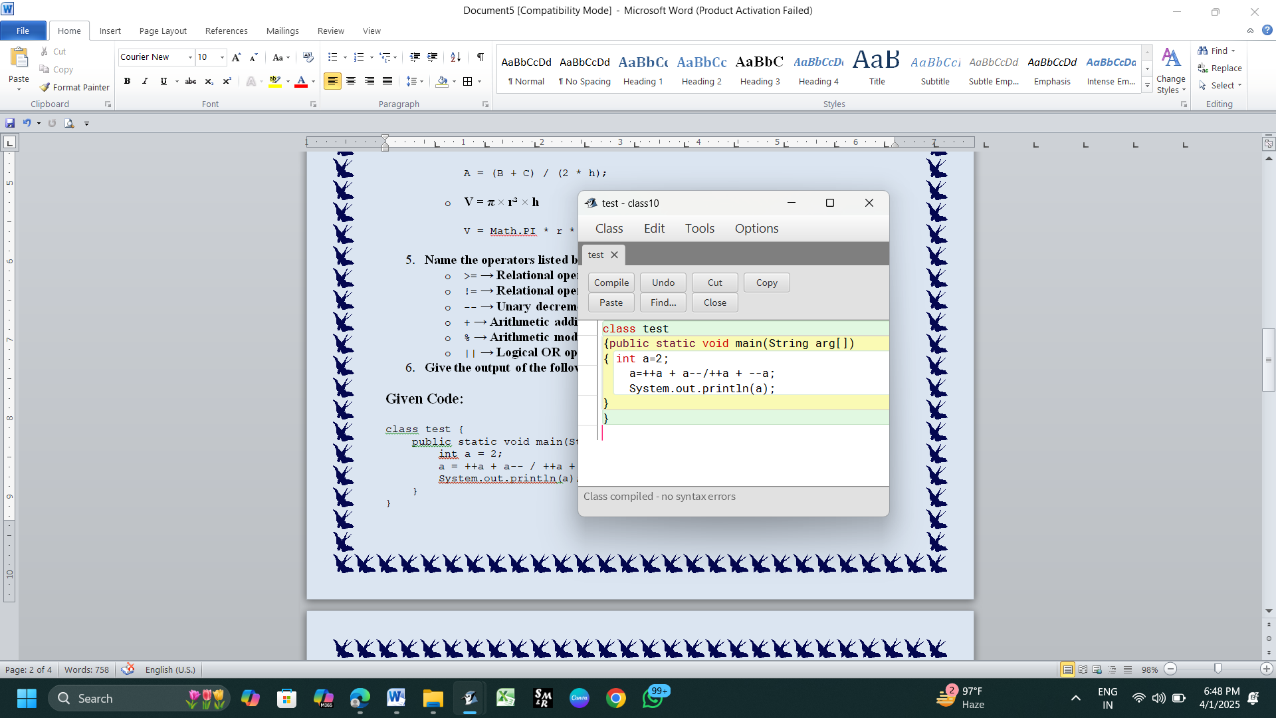
  - -- → Unary decrement operator
  - + → Arithmetic addition operator
  - % → Arithmetic modulus operator
  - || → Logical OR operator

- Give the output of the following expressions:

Given Code: 1st part
class test {
public static void main(String arg[])
{
int a = 2;
a = ++a + a-- / ++a + --a;
System.out.println(a);
}
}

Step-by-Step Execution:
- Initial Value: a = 2
- Evaluate ++a (Pre-increment, increases a first and then uses it)
  - ++a → a = 3
  - Value used: 3
- Evaluate a-- (Post-decrement, uses a first, then decreases)
  - Value used: a = 3
  - a-- → a = 2 (Now a = 2)
- Evaluate ++a (Pre-increment again)
  - ++a → a = 3
  - Value used: 3
- Evaluate --a (Pre-decrement, decreases a first)
  - --a → a = 2
  - Value used: 2

Substituting Values in Expression
a = 3 + 3 / 3 + 2
- Evaluate Division / First (According to Operator Precedence)
3 / 3 = 1
Now the expression reduces to:
a = 3 + 1 + 2
- Final Addition
a = 6

Final Output:
6

Key Learnings:
- Pre-increment (++a) → Increases the value first, then uses it.
- Post-decrement (a--) → Uses the value first, then decreases it.
- Operator Precedence: / (division) is evaluated before + (addition).
- Order of Execution Matters!
This expression contains a logic error (j++ % j-- / k * 10). Please clarify it properly.
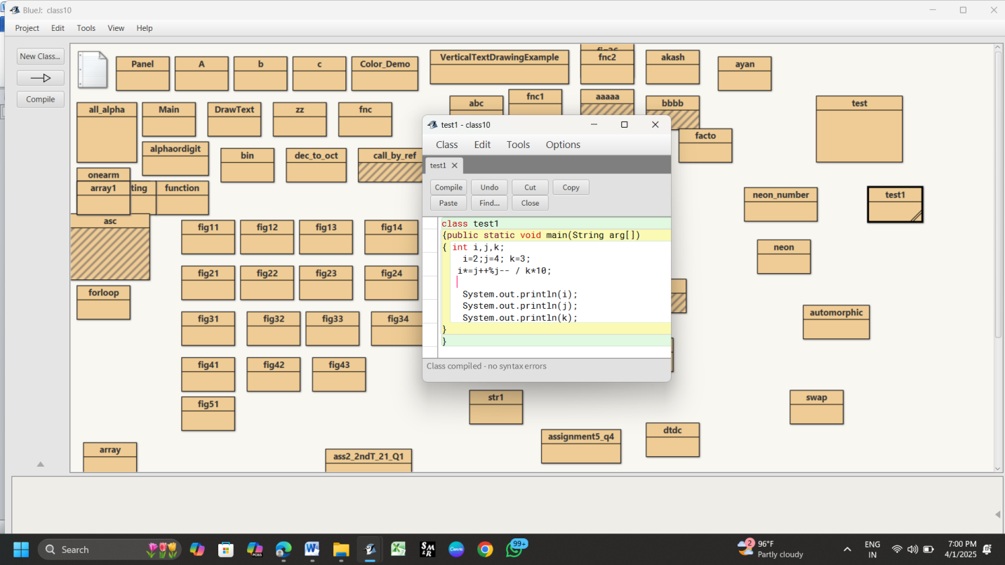
- Give the output of the following expressions: 2nd part

Given Code:
class test1 {
public static void main(String arg[]) {
int i, j, k;
i = 2;
j = 4;
k = 3;
i *= j++ % j-- / k * 10;
System.out.println(i);
System.out.println(j);
System.out.println(k);
}
}

Step-by-Step Execution:

Initial values:
i = 2
j = 4
k = 3

Evaluating the Expression:
i *= j++ % j-- / k * 10;
Since *= is shorthand for:
i = i * (j++ % j-- / k * 10);
We need to evaluate the right-hand expression step by step.

Step 1: Evaluate j++ (Post-increment)
- j++ means use the value of j first, then increment it.
- j = 4, so the expression uses 4 and then j becomes 5.
- So, we now have:
(4 % j-- / k * 10)
and j is now 5.

Step 2: Evaluate j-- (Post-decrement)
- j-- means use the value of j first, then decrement it.
- j = 5, so the expression uses 5 and then j becomes 4.
- So, we now have:
(4 % 5 / k * 10)
and j is now 4.

Step 3: Evaluate Modulus (%)
4 % 5 = 4
(Since 4 is smaller than 5, the remainder is 4.)
So, the expression now reduces to:
(4 / k * 10)
where k = 3.

Step 4: Evaluate Division /
4 / 3 = 1 (Since integer division in Java truncates the decimal part)
Now, the expression reduces to:
(1 * 10)

Step 5: Evaluate Multiplication *
1 * 10 = 10

Step 6: Evaluate i *=
i = i * 10
i = 2 * 10
i = 20

Final Values:
i = 20
j = 4
k = 3

Final Output:
20
4
3

Key Takeaways:
- Post-increment (j++): Uses j first, then increments.
- Post-decrement (j--): Uses j first, then decrements.
- Integer division (/): Truncates the decimal part.
- Operator precedence:
  - % (modulus) and / (division) have the same precedence and are evaluated from left to right.
  - * (multiplication) follows /.
  - *= is the last operation performed.
*************************************************

